Name-Raghav Aggarwal

SAP-ID-500091711

BBA(Analytics & Big data)

Web Analytics Assignment-

Website link- https://sites.google.com/view/raghav-aggarwal500091711/home

This was the website published by me and this is the website on which the google analytics is made.

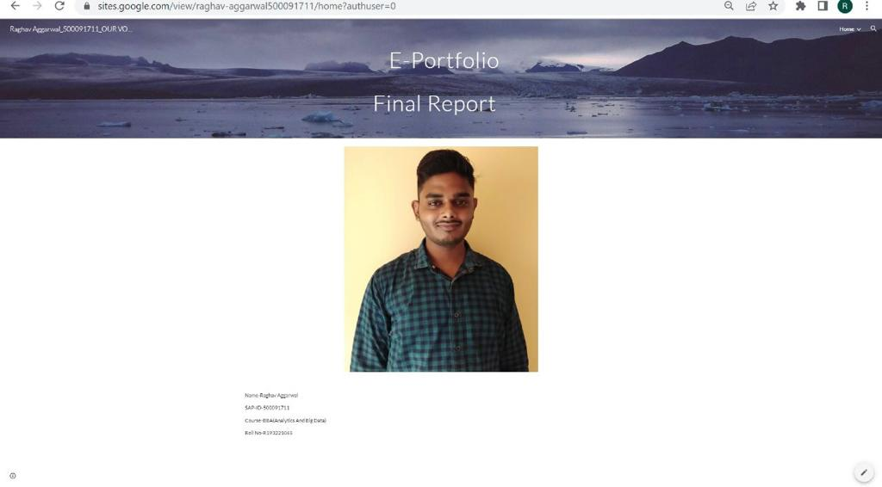

This page show the information about users and realtime reports on left side . you can see the avg analytics session is 30 minutes

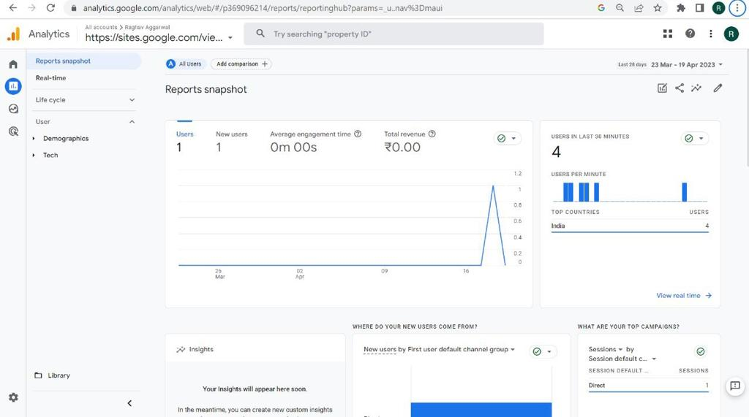

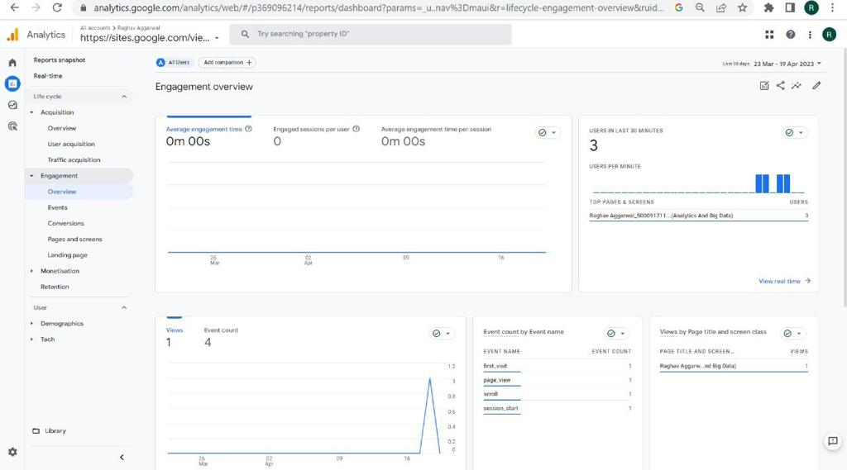

This image is showing the traffic acquisition

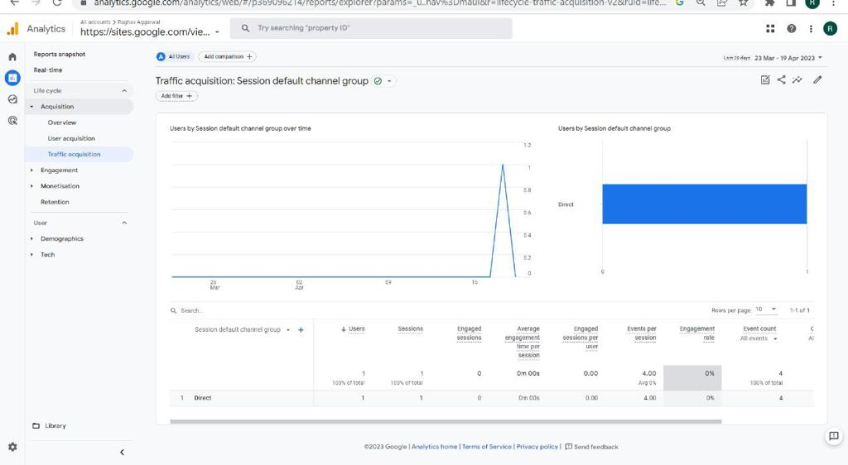

This image is showing that how many people have been visited in the last 30 minutes.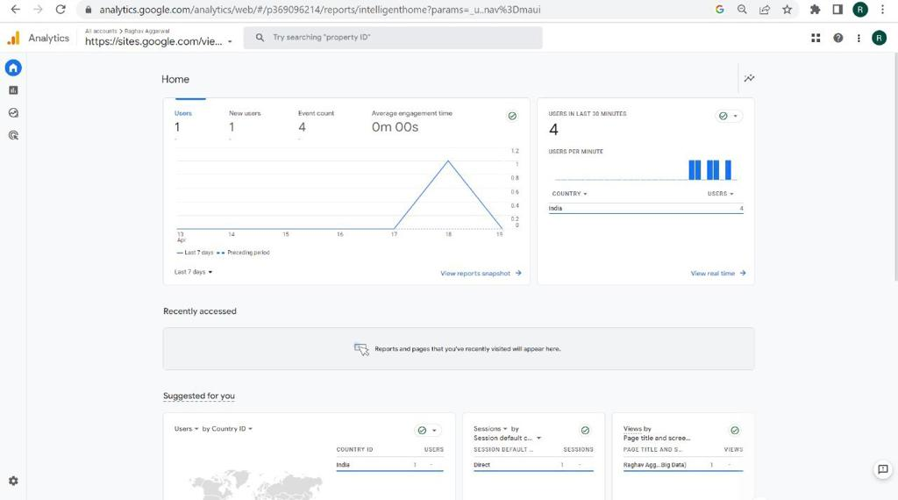

This image is showing the engagement overview of the people.

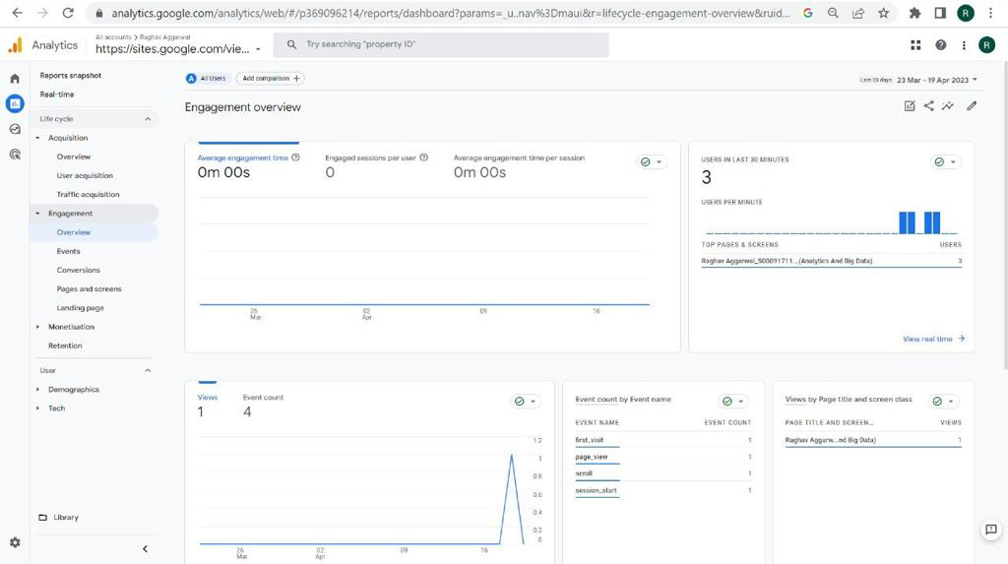

This is the real time data of the website.

